**Class Notes**

19-01-2021

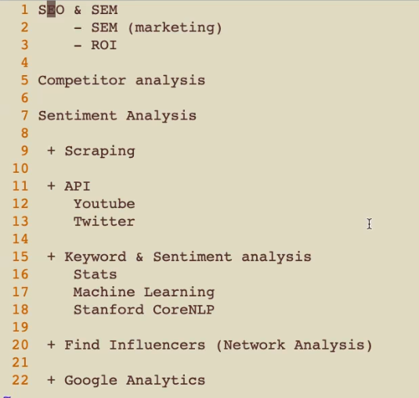

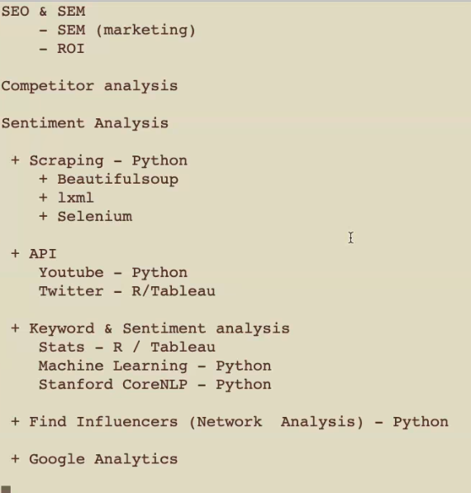

libraries to access APIs via Python:

<https://pypi.org/project/requests/>

<https://requests.readthedocs.io/en/master/>

20-01-2021

**Process of Social Media Analytics**

Step1: Authentication of Oath

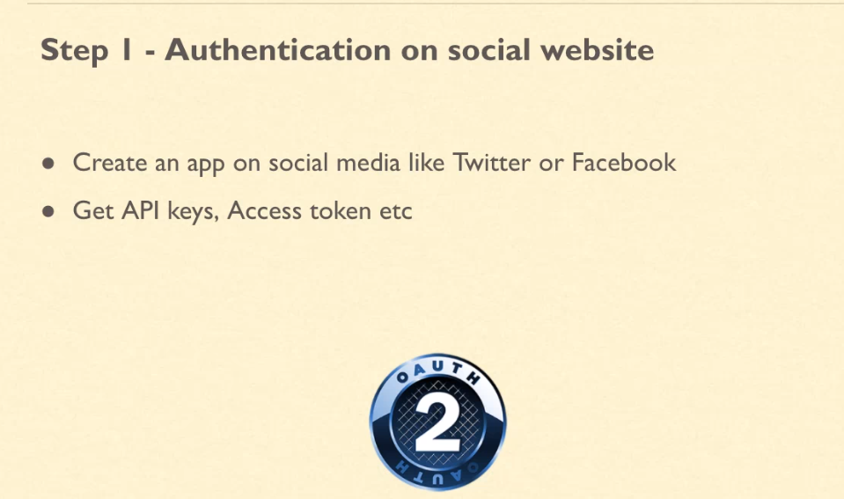

Step2: Get data using API

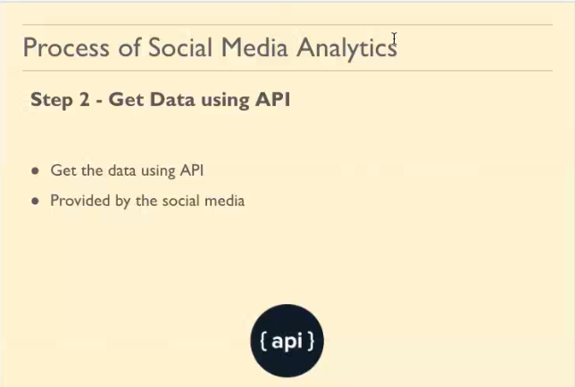

Step3: Cleaning Data

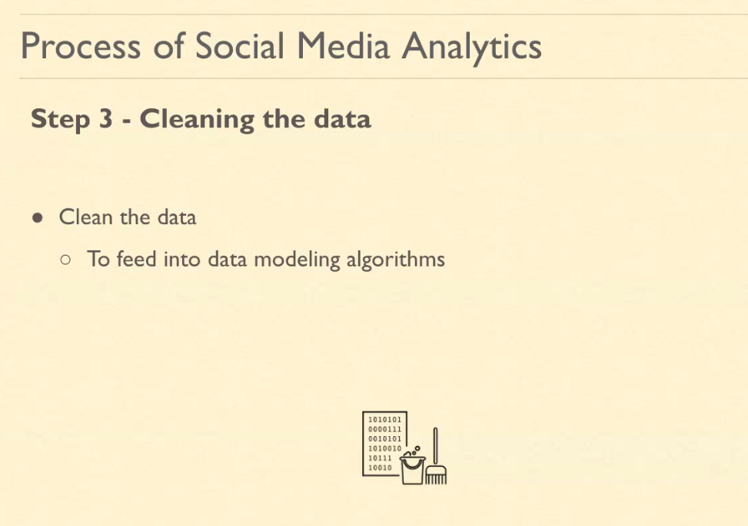

Step4: Data Modelling

Step5: Visualisation

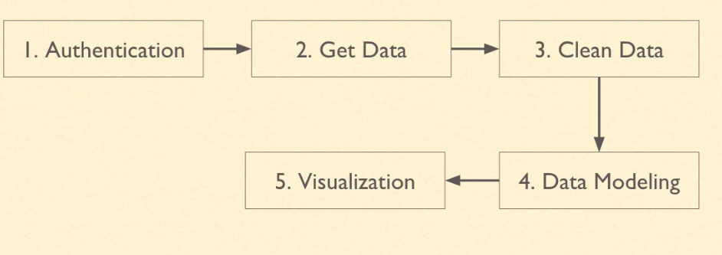

**Text Mining**: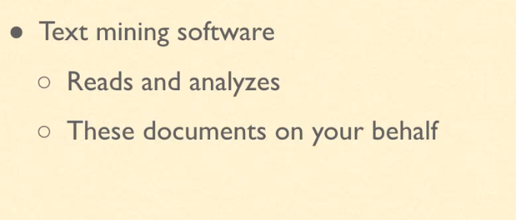

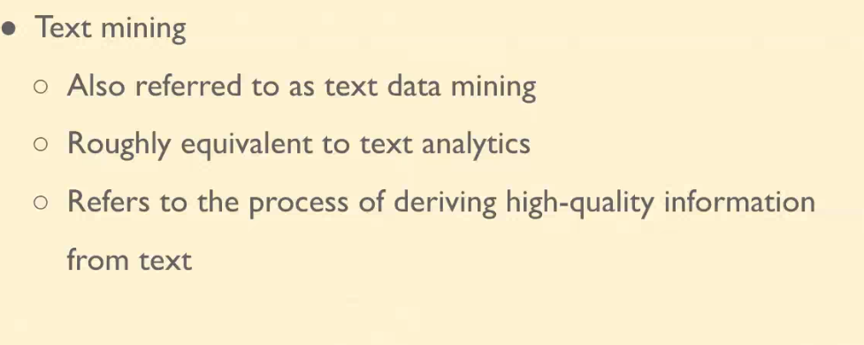

**NLP**

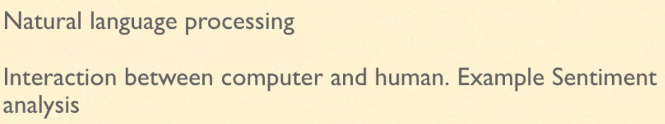

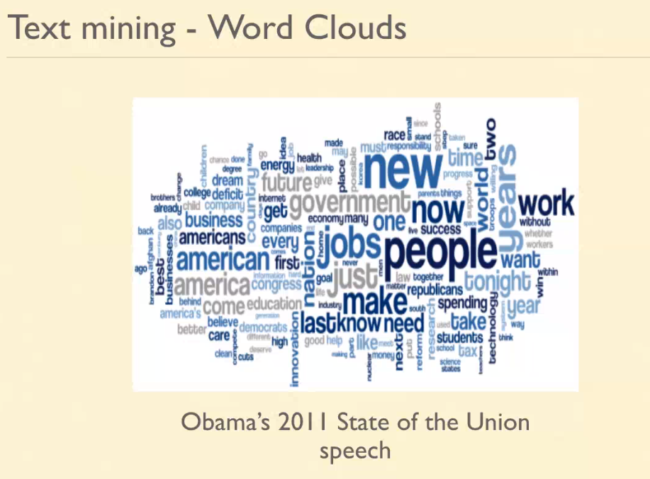

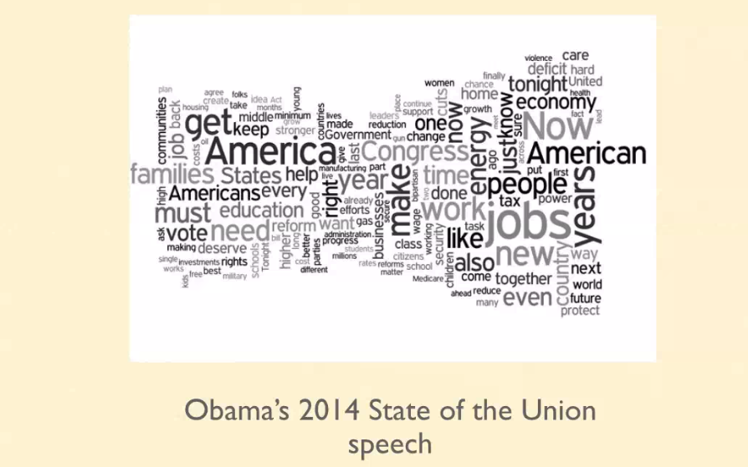

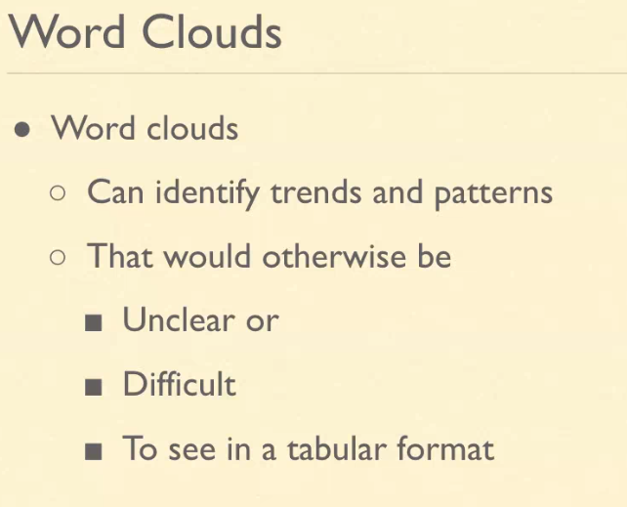

install.packages("twitteR")

install.packages("ROAuth")

install.packages("stringr")

install.packages("ggplot2", dependencies=TRUE)

install.packages("httr", dependencies=TRUE)

install.packages("wordcloud", dependencies=TRUE)

install.packages("RCurl", dependencies=TRUE)

install.packages("syuzhet", dependencies=TRUE)

install.packages("tm", dependencies=TRUE)

install.packages("plyr", dependencies=TRUE)

install.packages("dplyr", dependencies=TRUE)

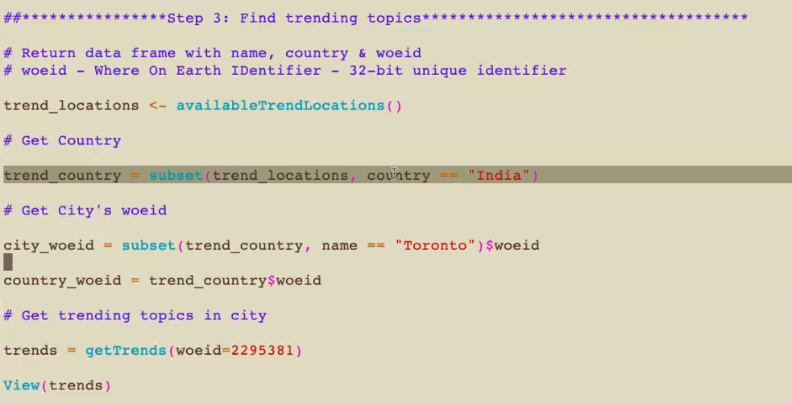

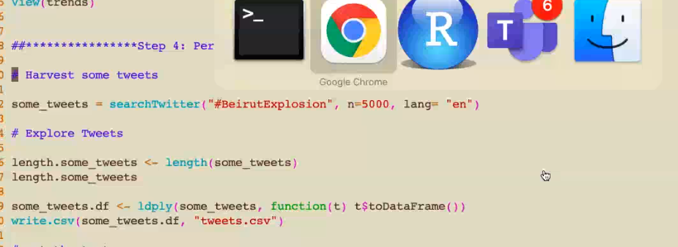

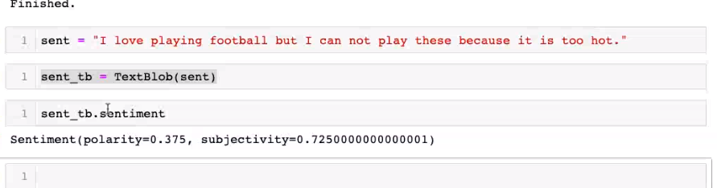

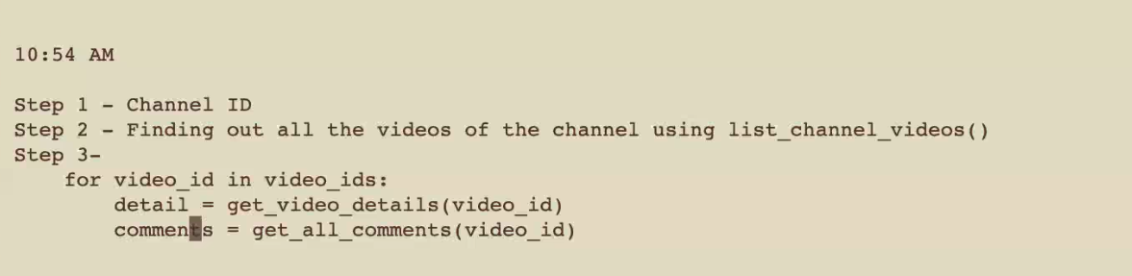

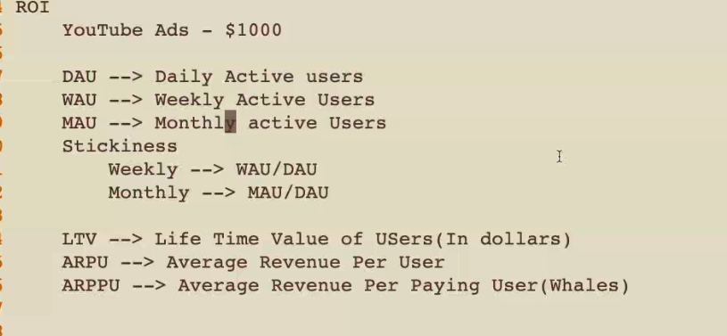

<https://analytics.google.com/analytics/academy/>